PROJECT REPORT

Gas Leakage Monitoring and Alerting System

|  |  |
| --- | --- |
| **TEAM ID** | PNT2022TMID25975 |
| **TEAM MEMBERS** | 1. DASA SARANYA  2. KRISTAVARAPU RAMYA SRI  3. VANGALA SOWMYA  4. RAGAVI.B |
| **BRANCH** | ELECTRONICS AND COMMUNICATION ENGINEERING |

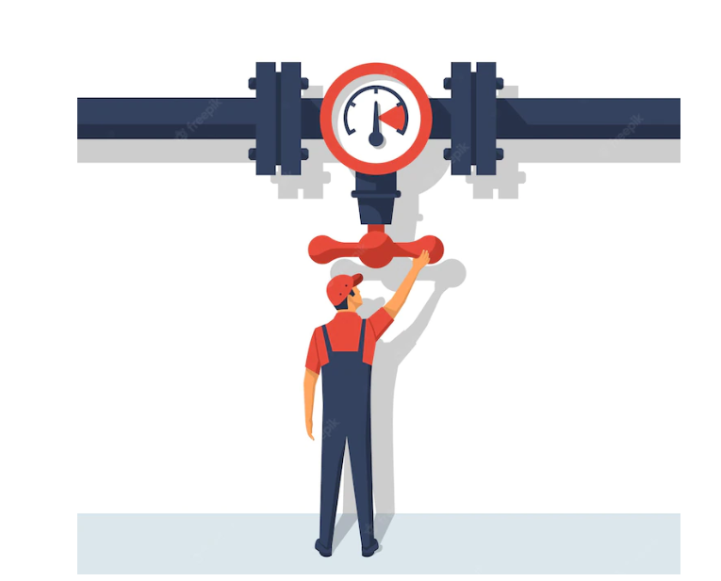

**TABLE OF CONTENTS**

* **INTRODUCTION**
  + Project Overview
  + Purpose
* **LITERATURE SURVEY**
  + Existing problem
  + References
  + Problem Statement Definition
* **IDEATION & PROPOSED SOLUTION**
  + Empathy Map Canvas
  + Ideation & Brainstorming
  + Proposed Solution
  + Problem Solution fit
* **REQUIREMENT ANALYSIS**
  + Functional requirement
  + Non-Functional requirements
* **PROJECT DESIGN**
  + Data Flow Diagrams
  + Solution & Technical Architecture
  + User Stories
* **PROJECT PLANNING & SCHEDULING**
  + Sprint Planning & Estimation
  + Sprint Delivery Schedule
  + Reports from JIRA
* **CODING & SOLUTIONING (Explain the features added in the project along with code)**
  + Feature 1
  + Feature 2
* **TESTING**
  + Test Cases
  + User Acceptance Testing
* **RESULTS**
  + Performance Metrics
* **ADVANTAGES & DISADVANTAGES**
* **CONCLUSION**
* **FUTURE SCOPE**
* **APPENDIX**
  + Source Code
  + GitHub & Project Demo Link

**Introduction:**

* **Project Overview-**

Safety is of the biggest importance in today's environment, and certain precautions must be taken both at work and at home to assure it. Whether the topic is electricity or oil and gas, working or living in a hazardous environment requires certain safety measures."Liquified Petroleum Gas" (LPG), a kind of natural gas, is compressed under high pressure and kept in a metal cylinder. Leaving LPG exposed next to any fire source can cause catastrophic harm because it is highly flammable. LPG is more widely available than any other natural gas and is largely used for cooking. Sadly, due to its widespread use, gas leaks and even explosions are frequent occurrences. Consequently, a system for gas leaks are necessary. The system will monitor fire and flame using a flame sensor. When a fire is found, the buzzer starts to ring. Tests have demonstrated that the device can monitor gas leaks and wastage and alert the user. The demonstration that was put on demonstrated that it was effective in cutting down on the amount of domestic gas wasted.

* **Purpose-**

These days, a home safety detection system is crucial to people's security. Since everyone in the household works every day, it is impossible to check on the household appliances, particularly the LPG gas cylinder, wired circuits, etc. Liquefied petroleum gas (LPG) and natural gas demand has significantly increased during the past three years. LPG and natural gas are recommended to meet this high level of energy demand and to substitute oil or coal due to those fuels' negative environmental effects. Large-scale industrial uses for these gases include heating, home appliances, and motor fuel. The system has a gas detector to keep an eye on this gas leak. This sensor measures the quantity of gas leakage that is present in the atmosphere around it. This will help to prevent the negative effects of an explosion or gas leak.

**Literature Survey:**

* **Existing Problems-**

The goal of the Internet of Things is to simplify our lives by automating all of the little tasks around us. The advantages of IoT can be extended to improving the current safety standards in addition to helping to automate jobs. IoT has not been immune to the fundamental worry of any project, safety. Gas leaks can be fatal and harmful, whether they occur in open or closed spaces. Despite their high level of precision, conventional gas leak detection systems overlook a few important aspects of warning others of a leak. In order to create a Gas Leakage Detector for a society with Smart Alerting procedures that involve texting the appropriate authority in case of an emergency and the capability to run data analyses on sensor readings, we employed Internet of Things technology. Our main goal is to provide a gas leak detection system for a society in which every apartment has gas leak detecting equipment. This will identify dangerous substances in the air and notify society members by sending out alarms and messages.

* **References-**
* <https://www.academia.edu/81270911/IoT_Based_LPG_Gas_Level_Detection_and_Gas_Leakage_Accident_Prevention_with_Alert_System?f_ri=241365>
* <https://www.semanticscholar.org/paper/Gas-leakage-detection-and-alerting-system-using-Uno-Shahewaz-Prasad/176f9c7c278524425b7c9ff9491ee1f2a0095b4b>
* <https://jeeeccs.net/index.php/journal/article/view/172>
* <https://www.pramanaresearch.org/gallery/22.%20feb%20ijirs%20-%20d539.pdf>
* <https://www.researchgate.net/figure/Comparison-of-gas-detection-sensor-technologies_tbl2_285988329>
* <https://ieeexplore.ieee.org/document/8822055>
* <https://ijsrcseit.com/CSEIT1951128>
* <http://repository.psa.edu.my/bitstream/123456789/3134/1/GAS%20DETECTOR>
* **Problem Statement Definition –**

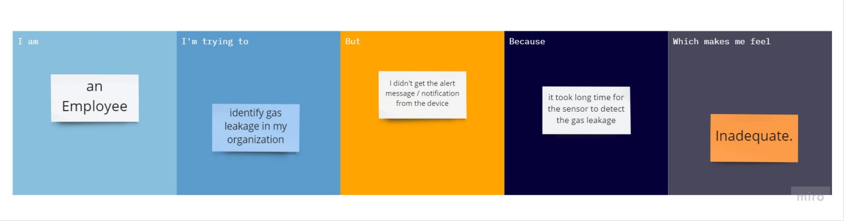

**Ideation and Proposed Solution:**

* **Empathy Map:**

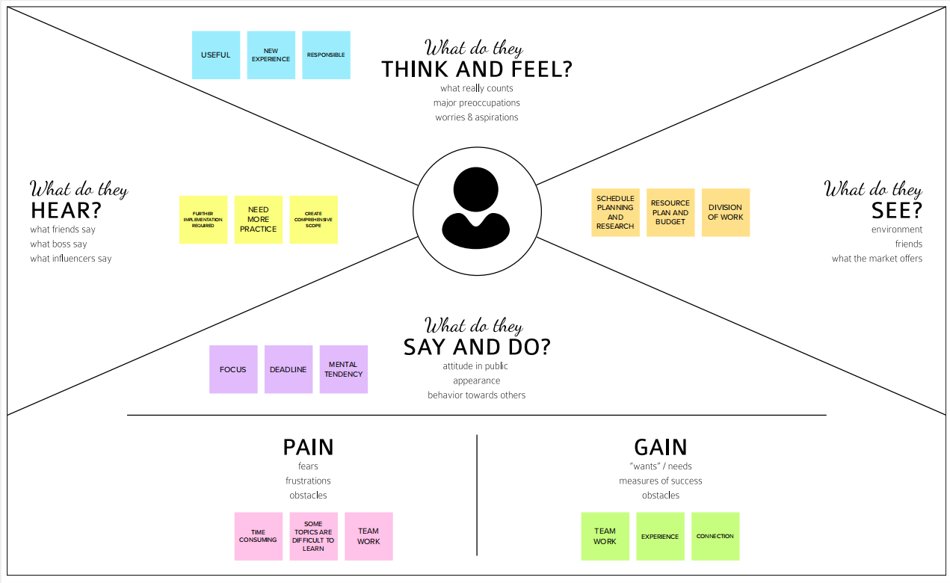

* **Ideation and Brain Storming:**

Gas detector sensors, an Arduino board, an ESP8266, and a cloud server make up the system. All flat member users can be registered on our system by a single society authority person. The administrator of the society can enter information on each flat's users, including their user name, phone number, and flat sensor information. Each sensor's threshold value can be set by society admin. Each flat can be equipped with system hardware. The value per time can be sensed using sensors. Values can be sent from the system to a cloud server. The sensor values' existence at the threshold value can be checked by the server. The server can instruct the hardware to buzz the alert if the sensor value can exceed the limit. Additionally, the server notifies the user. In this study, we employ IOT technologies to raise the bar for current safety regulations. The goal of creating this prototype was to revolutionize environmental safety by eliminating any major or minor hazards brought on by the release of hazardous and dangerous gases into the environment.

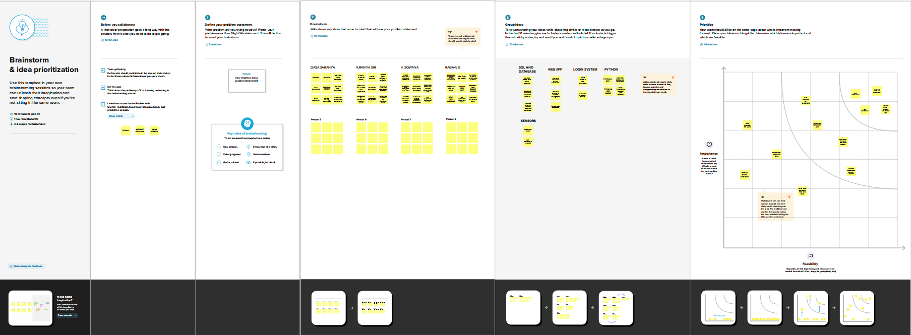

* **Proposed Solution:**

|  |  |  |
| --- | --- | --- |
| **S.No.** | **Parameter** | **Description** |
|  | Problem Statement (Problem to be solved) | To detect the leakage of gas in industries. The number of deaths due to explosion of gas leakage has been increased in recent years.  The BHOPAL GAS TRAGEDY is example for this. |
|  | Idea / Solution description | Web-app is developed to get notification and this system is used to detect different types of chemical gases and the device is fixed so we can get 24/7 surveillance. |
|  | Novelty / Uniqueness | Recent applications can only detect only one gas component and sensitivity depends on temperature and humidity but the device that’s going to be develop here is able to detect multiple types of gas components and it’s a fixed device so there’s no chance for privation. Here we use sensors to detect the gas concentration in atmosphere and based on the given data to the sensor from the makers, it’ll indicate or alert the admins with the location through web-app and also through buzzer system when there’s a problem. |
|  | Social Impact / Customer Satisfaction | This will help the industry in monitoring emission of harmful gases and with the help of integrated sensors multiple types of harmful gas emissions can be detected we can get the sensor parameters in the web-app and also get notification about danger in the app itself. |
|  | Business Model (Revenue Model) | It helps to reduce vulnerability in harmful situations and also gives assurance to staff to work efficiently. |
|  | Scalability of the Solution | The aim of this paper is to propose and discuss a design of a gas leakage detection system that can automatically detect, alert and control gas leakage. This proposed system also includes an alerting system for the users. The system is based on a sensor that easily detects a gas leakage. The need for ensuring safety in workplace is key driving force for the project. |

* **Problem Solution Fit:**

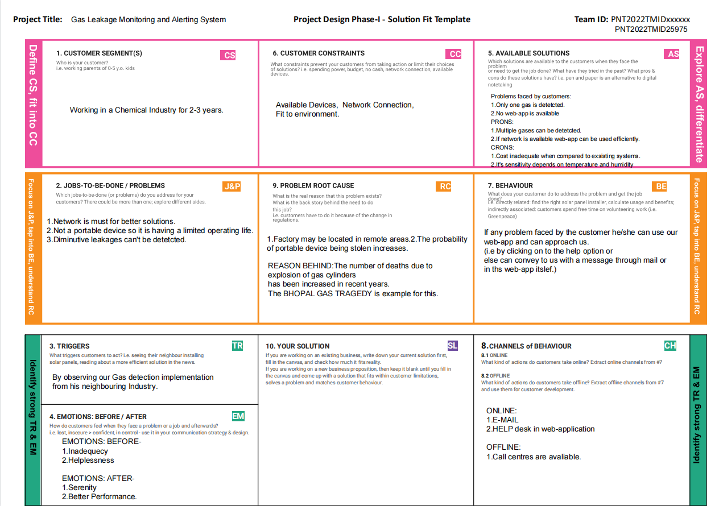

**Requirements Analysis:**

* **Functional Requirements:**

Following are the functional requirements of the proposed solution.

|  |  |  |
| --- | --- | --- |
| **FR No.** | **Functional Requirement (Epic)** | **Sub Requirement (Story / Sub-Task)** |
| FR-1 | User Registration | Registration through Form  Registration through G-mail  Registration through Linked In |
| FR-2 | User Confirmation | Confirmation via Email  Confirmation via OTP |
| FR-3 | Data fetch | The details of the gas leaked will be transferred to IOT system. |
| FR-4 | Methodology | It is a well way to get rapid results in a short time. |
| FR-5 | Receiving in the user end | Gas level details will be displayed through LCD, an alarm will be beeps and the same data will be sent to the user mobile or PC. |
| FR-6 | Transferring to user | IOT, WIFI module. |
| FR-7 | sensitivity | Specialized of the gas in all similar systems |
| FR-8 | User Interface and operation | The system be operated in android operating system. Emergency call, message with application systems. |

* **Non-Functional Requirements:**

Following are the non-functional requirements of the proposed solution.

|  |  |  |
| --- | --- | --- |
| **FR No.** | **Non-Functional Requirement** | **Description** |
| NFR-1 | **Usability** | Prevent gas leakage and also detect it. |
| NFR-2 | **Security** | Info of user should not be shared and advancement can be done to get avoided from risk. |
| NFR-3 | **Reliability** | Accurate and can suit and adapt any environment. |
| NFR-4 | **Performance** | Response is faster and detect smaller leaks. |
| NFR-5 | **Availability** | Should be available around the clock. |
| NFR-6 | **Scalability** | Good performance and easy to use. |

**Requirements Analysis:**

* **Data Flow Diagram-**

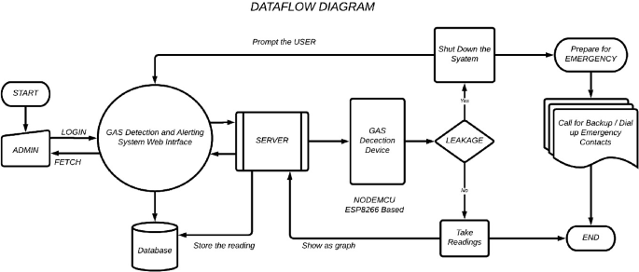

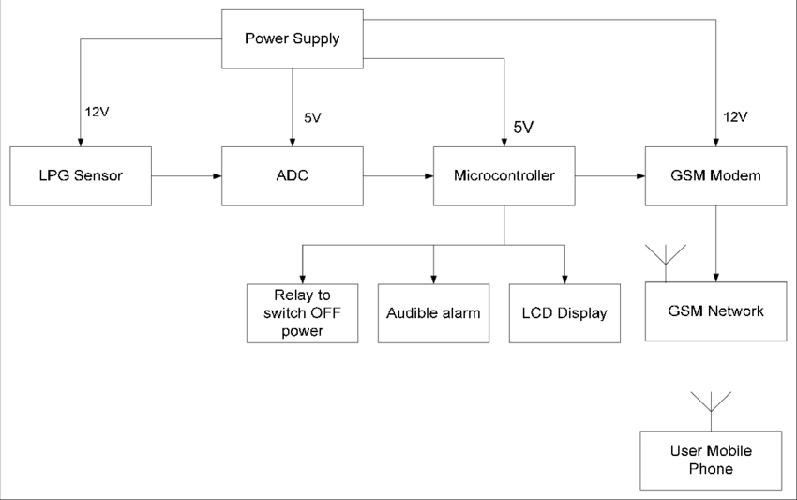

* **Solution and Technical Architecture-**

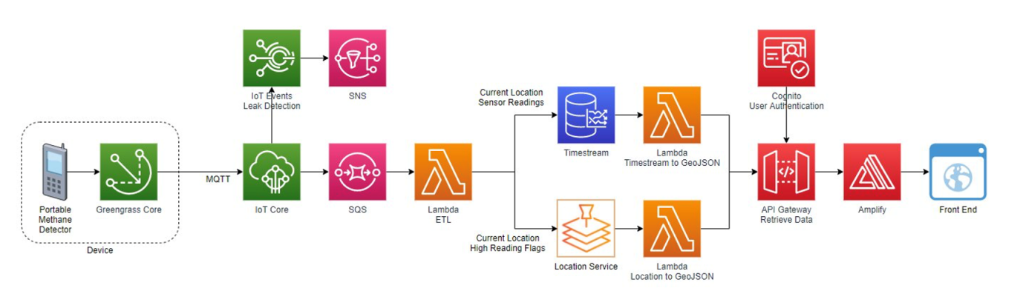

* **User Stories-**

The system might be seen as a modest attempt to link together the principal gas detection techniques now in use with a mobile platform coupled with IoT platforms. The gases are detected within a 1 m radius of the rover, and sensor output data is continually sent to a nearby server. Stray gases are also detected since the sensors' accuracy isn't good enough, which causes some mistake in their outputs, particularly in the case of methane. Testing the integrated hardware is further complicated by the storage and availability of hazardous gases like H2S. Because the system functions outside of the pipeline, maintaining it and choosing the right materials for it in the event. As the system operates outside the pipeline. The complication of system maintenance and material selection of the system in case of corrosive gas is reduced thus, the system at this stage can only be used as a primary indicator of leakage inside a plant.

**Project Planning and Scheduling:**

* **Sprint Planning and Estimation-**
* SPRINT PLAN
* PROBLEM ANALYSIS
* PROBLEM STATEMENT PREPARATION
* LIST OF REQUIRED OBJECTS
* PROGRAM CODE CREATION AND RUNNING
* PROGRAM PROTOTYPE
* TEST USING THE CREATED CODE AND CONFIRMATION OF THE DESIGNED PROTOTYPE
* **Sprint Delivery Schedule-**
* Sprint 01
* Sprint 02
* Sprint 03
* Sprint 04

It’s followed accordingly.

* **Reports from JIRA-**

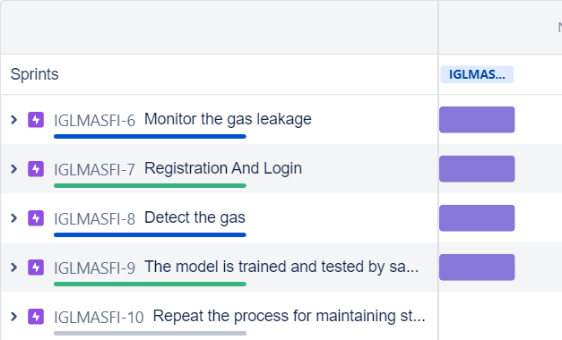

|  |  |  |
| --- | --- | --- |
| **Sprint** | **Functional Requirement (Epic)** | **User Story / Task** |
| Sprint-1 | Monitor the gas leakage | The Industrialist have own industries so the  industry owner must take of workers.The  workers have family so the industries give  security assurance of workers. |
| Sprint-1 | Registration  And Login | As a user, can register for the application by entering email, password, and confirming password. User will receive confirmation email once have registered for the application. |
| Sprint-2 | Avoid from Disaster | The gas leakage occur at the time fire service will take care to protect the people from the disaster. |
| Sprint-3 | Detect the gas | We have monitor the gas by 24/7 hrs. To avoid leakage,the industry have quality pipes to transfer the gas and proper maintanence service once in a month. The industry must take care of what are the necessary process to avoid the gas leakage. |
| Sprint-3 | The model is trained  and tested by sample  dataset. | The programmer designs the model to detect the  gas leakage. |
| Sprint- 4 | sensor value < threshold value | As a user, I should get an indication through  red LED. |
| Sprint-4 | Repeat the process for  maintaining strict safety with warning message. | In case any gas leakage occurs, the device gives the alarm and alert message to concerned user within a minute. |

**Schematic diagram of Project & Components:**

* **Circuit Diagram-**

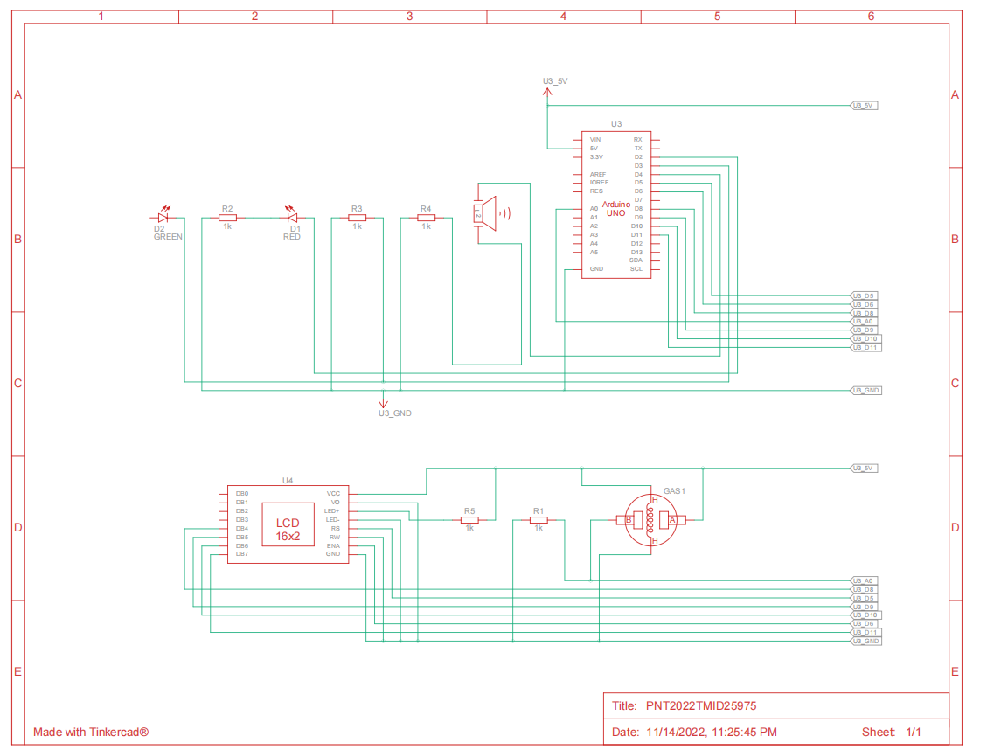

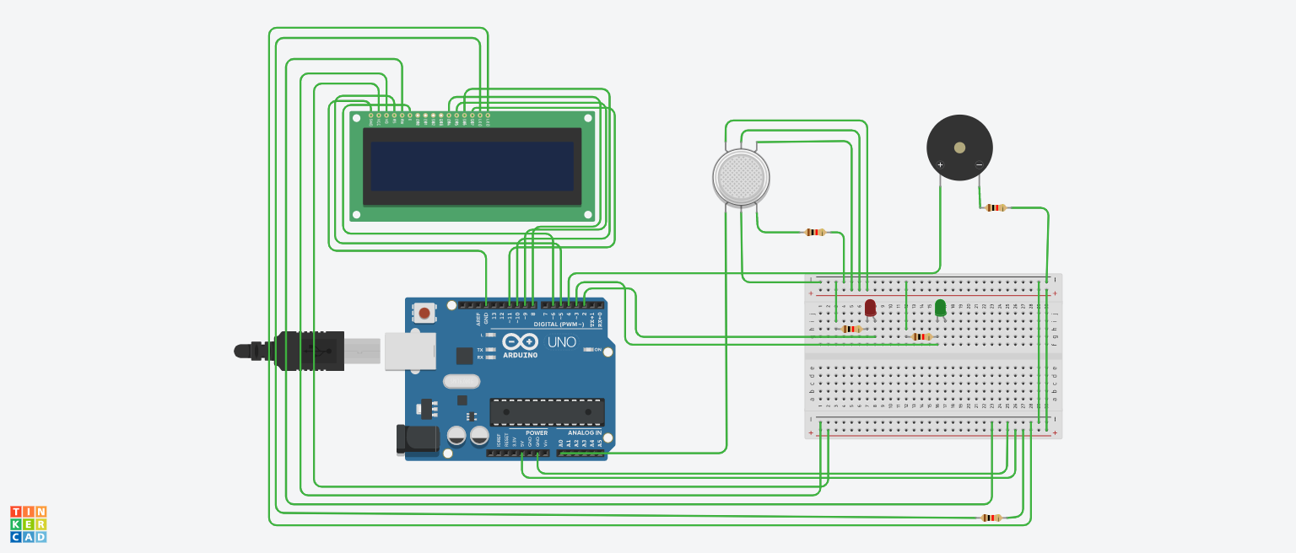

* **List of Components:**

|  |  |  |
| --- | --- | --- |
| **S. No** | **Name of the Component** | **Quantity** |
| 1. | Arduino UNO R3 | 1 |
| 2. | Breadboard | 1 |
| 3. | LED | 2 |
| 4. | Resistor | 5 |
| 5. | Piezo | 1 |
| 6. | Gas Sensor | 1 |
| 7. | LCD 16*2 | 1 |
| 8. | Potentiometer | 1 |

The required [basic electronics components](https://www.elprocus.com/basic-components-used-electronics-electrical/) for designing a microcontroller based LPG leakage detector circuit mainly include Arduino Pro Mini, LPG gas sensor module, buzzer, BC 547 transistor, 16×2 LCD, 1K resistor, bread board, 9 volt battery and connecting wires.

**Piezo:**

A piezo is a device that generates a voltage when force is applied or

becomes deformed when voltage is supplied.

**Resistor:**

A passive electrical component with two terminals that are used for

either limiting or regulating the flow of electric current in electrical circuits.

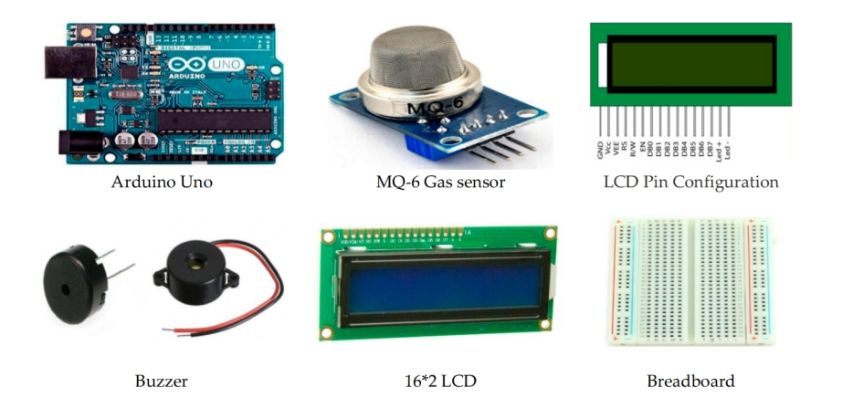

**Gas Sensors:**

Electronic devices called gas sensors (sometimes referred to as gas detectors) are used to locate and classify various gases. They are frequently employed to gauge gas concentrations and identify explosive or dangerous gases. Gas sensors are used in manufacturing facilities and factories to find gas leaks and to detect smoke and carbon monoxide in residential buildings. Gas sensors come in a wide range of sizes (portable and fixed), sensing capabilities, and ranges. They frequently function as a component of a larger embedded system, such as security and hazmat systems, and are typically connected to an interface or audible alarm. Gas sensors require more frequent calibration than many other types of sensors since they are continually reacting with air and other gases.

**Arduino Uno:**

A micro controller board called Arduino UNO is based on the ATmega328P. It contains 6 analogue inputs, a 16 MHz ceramic resonator, 14 digital input/output pins (six of which can be used as PWM outputs), a USB port, a power jack, an ICSP header, and a reset button. It comes with everything needed to support the micro controller; to get started, just plug in a USB cable, an AC-to-DC adapter, or a battery. You can experiment with your UNO without being overly concerned that you'll make a mistake; in the worst case, you can replace the chip for a few dollars and start over.

**LCD:**

Liquid crystal display is referred to as LCD. It is a particular type of electronic display module used in a wide array of circuits and devices, including mobile phones, calculators, computers, TVs, and other electronics. These displays are mostly preferred for seven segments and multi-segment light-emitting diodes. The main advantages of adopting this module are its low cost, ease of programming, animations, and unlimited ability to display bespoke characters, unique animations, etc. The LCD device's inexpensive cost and low power consumption are two of its key benefits. So these LCDs run on AC power that has a frequency of less than 500 Hz.

**BUZZER:**

A beeper or buzzer, for example, could be electro-mechanical, piezoelectric, or mechanical in design. The signal is converted from audio to sound as its primary function. It is often powered by DC voltage and used in timers, alarm clocks, printers, computers, and other electronic devices. It can produce a variety of sounds, including alarm, music, bell, and siren, according on the varied designs.

**Coding and Solutions:**

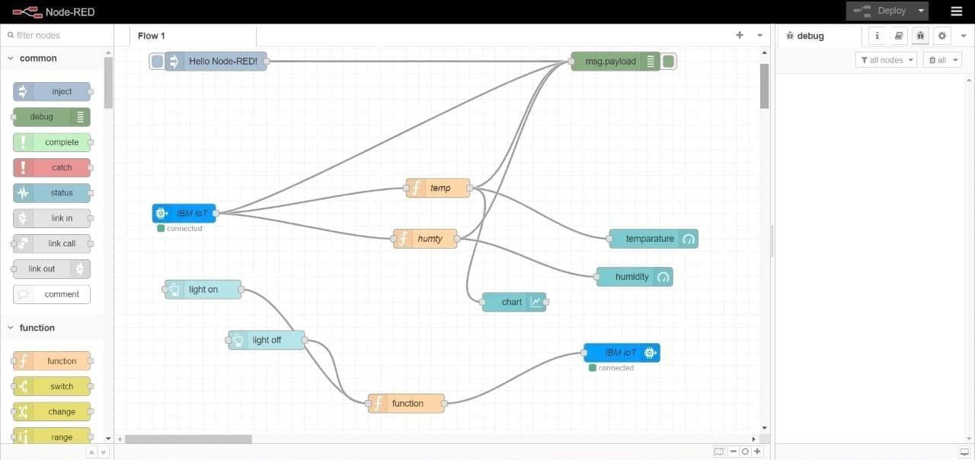

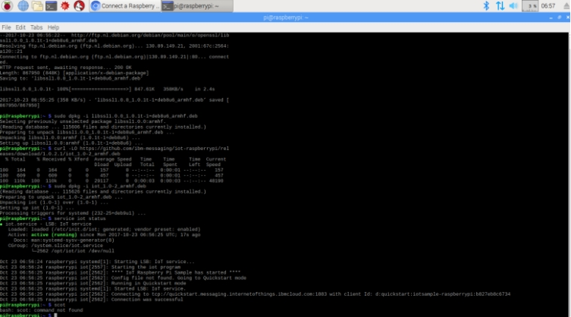

**Results:**

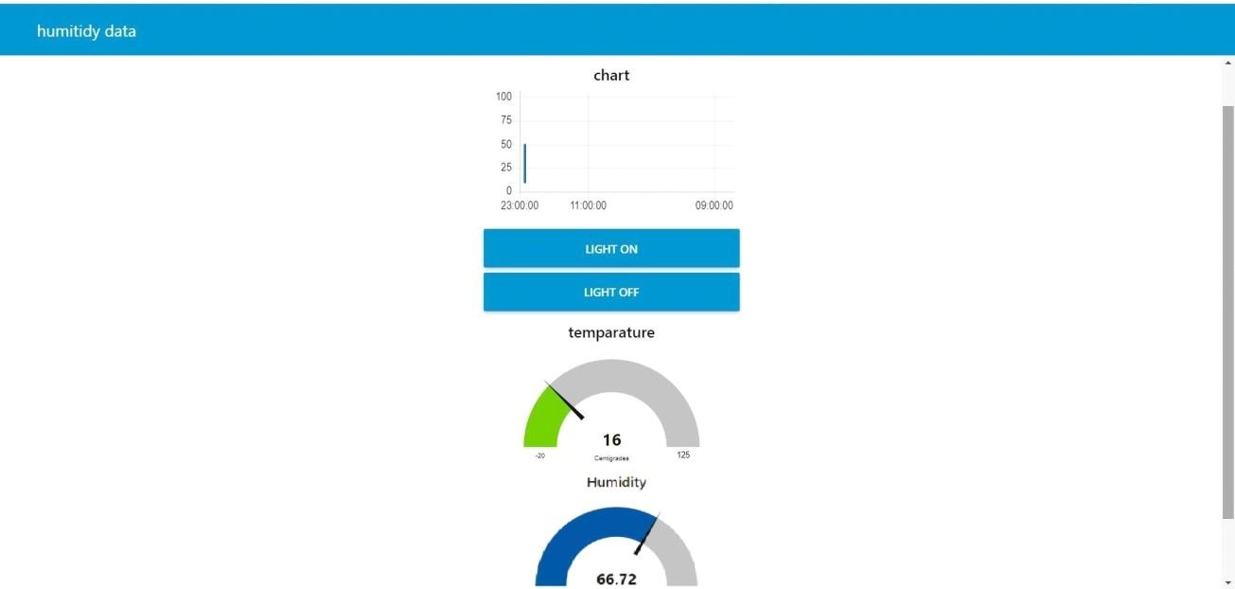

**Advantages and Disadvantages:**

* **Advantages:**

This can also be connected to the Internet for available readings at any given time. This allows all safety managers to view gas levels at all points of the project. Systems of this nature are especially beneficial on work sites in which there have been previous accidents and leaks. It is also a great way to closely monitor confined spaces in which higher gas levels can nearly instantly turn the air into poison. These are also made to withstand a wider range of temperatures and weather changes. Hardwired systems sometimes tend to fail in particularly harsh winter climates; wireless detectors can withstand temperatures all the way down to -40 degrees Fahrenheit.

* **Disadvantages:**

Anyone looking for an inexpensive detector to do the bare minimum of what is necessary under the law will not be happy with a wireless system. Safety is one of the most important aspects of running a business, especially one that encounters these types of dangers on a regular basis. If you are concerned about budget, a hardwired system will still get the job done. All things considered, the reliability and real-time level monitoring provided by wireless gas detection systems makes them the top-of-the-line [solution for gas leaks](http://www.gdscorp.com/blog/the-major-functions-of-a-propane-gas-detector/). The initial cost may be enough to deter you from pursuing this option, but consider what type of business you run.

**Conclusion:**

We can infer from the project's performance that the system's detection of gas leakage is remarkable. Useful for both residential and commercial purposes. We can use this technique to save lives in dangerous situations. The GSM module indicates an alert. Propane, CO2, and other gases are detected by a sensor node. Power usage and transmission range are estimated. The sensor was constructed using simple techniques and an Arduino UNO Micro controller.

**Future Scope:**

The Smart Industrial application, which includes a gas monitoring system, is being promoted in major Indian cities. IoT-enhanced improvement of industrial safety IoT transforms a drone into a gas detector.  Incorporating an Automatic Shut-off mechanism that will cut off the gas supply whenever it detects a gas leak could be another important future development. This system can be used in businesses, lodging facilities, and wherever else that gas systems are used. This system can be employed in sectors that use applications like furnaces, boilers, gas welding, gas cutting, steel plants, metalworking, food processing, glass, plastic, pharmaceutical, and aerosol manufacturing. This method can be used to maintain track of all the cylinders used in hospitals, which are required to give patients with the highest level of safety possible. The cylinders utilized include those for oxygen, carbon dioxide, and nitrous oxide. The likelihood of accidents occurring is high because so many pupils are naive. So, schools and colleges can also use our system. There are several colleges with well-established laboratories, such as chemistry labs and pharmaceutical labs that employ gas burners. Numerous medical devices need gas cylinders.

**Appendix:**

* **SOURCE CODE:**

#include <LiquidCrystal.h>

LiquidCrystal lcd(6, 7, 8, 9, 10, 11);

float gasPin = A0;

float gasLevel;

int ledPin = 2;

int buttonPin = 3;

int buzzPin = 4;

int buttonState;

int fan = 5;

void setup(){

pinMode(ledPin, OUTPUT);

pinMode(buttonPin, INPUT);

pinMode(gasPin,INPUT);

pinMode(fan,OUTPUT);

Serial.begin(9600);

lcd.begin(16, 2);

lcd.setCursor(0,0);

lcd.print(" Welcome");

lcd.setCursor(0,2);

lcd.print("PNT2022TMID51246");

delay(500);

lcd.clear();

}

void loop(){

// Read the value from gas sensor and button

gasLevel = analogRead(gasPin);

buttonState = digitalRead(buttonPin);

// call the function for gas detection and button work

gasDetected(gasLevel);

buzzer(gasLevel);

exhaustFanOn(buttonState);

}

// Gas Leakage Detection & Automatic Alarm and Fan ON

void gasDetected(float gasLevel){

if(gasLevel >= 200){

digitalWrite(buzzPin,HIGH);

digitalWrite(ledPin,HIGH);

digitalWrite(fan,HIGH);

lcd.setCursor(0,0);

lcd.print("GAS:");

lcd.print(gasLevel);

lcd.setCursor(0,2);

lcd.print("FAN ON");

delay(1000);

lcd.clear();

}else{

digitalWrite(ledPin,LOW);

digitalWrite(buzzPin,LOW);

digitalWrite(fan,LOW);

lcd.setCursor(0,0);

lcd.print("GAS:");

lcd.print(gasLevel);

lcd.setCursor(0,2);

lcd.print("FAN OFF");

delay(100);

lcd.clear();

}

}

//BUZZER

void buzzer(float gasLevel){

if(gasLevel>=200)

{

for(int i=0; i<=30; i=i+10)

{

tone(4,i);

delay(400);

noTone(4);

delay(400);

}

}

}

// Manually Exhaust FAN ON

void exhaustFanOn(int buttonState){

if(buttonState == HIGH){

digitalWrite(fan,HIGH);

lcd.setCursor(0,0);

lcd.print("Button State:");

lcd.print(buttonState);

lcd.setCursor(0,2);

lcd.print("FAN ON");

delay(10000);

lcd.clear();

}

}

**RESULT:**

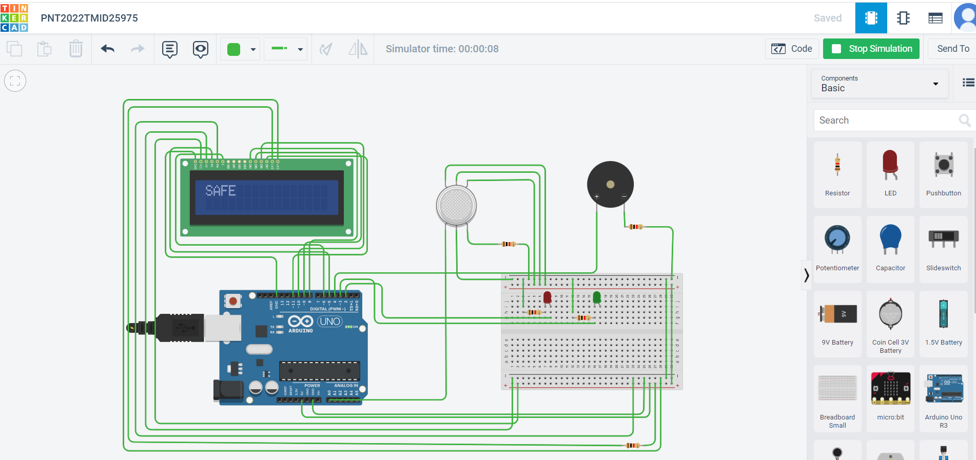

* **Github and Project link:**

**GITHUB LINK OF PROJECTS:**

<https://github.com/IBM-EPBL/IBM-Project-1867-1658418840>

**TINKERCAD LINK:**

<https://www.tinkercad.com/things/5tVUe79RNwJ-copy-of-gas-leakage/editel?sharecode=nZ06emNvmedYTaLEH7R_7ZjJ8oDiwB1xMxojrN9hNNQ>

**DEMO LINK:**

<https://drive.google.com/file/d/1LNuRfVAab66eT3xEWG2C-QZO56TkC_4u/view?usp=sharing>